Conceptual Data Model

🌟 Definition
# Source: AI Source: Provided by: [Data Path: Persons Table -> ID Column: 1, Name_En Column: Motasem Essam] -> From: [ChatGPT] on [6/10/2026]
A Conceptual Data Model is the highest-level and most abstract view of a database system.
It focuses on:
What data is needed?
How is the data related?
without worrying about:
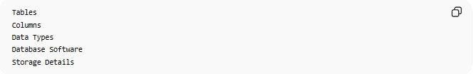
Tables
Columns
Data Types
Database Software
Storage Details

🎯 Purpose
# Source: AI Source: Provided by: [Data Path: Persons Table -> ID Column: 1, Name_En Column: Motasem Essam] -> From: [ChatGPT] on [6/10/2026]
The Conceptual Data Model is used to:
- Understand business requirements
- Identify important data entities
- Define relationships between entities
- Communicate with stakeholders
- Create the foundation for later database design

🧠 Key Question
# Source: AI Source: Provided by: [Data Path: Persons Table -> ID Column: 1, Name_En Column: Motasem Essam] -> From: [ChatGPT] on [6/10/2026]
A Conceptual Model answers:
What information does the business need?
Not:
How will the database store it?

📚 Example: Online Store
# Source: AI Source: Provided by: [Data Path: Persons Table -> ID Column: 1, Name_En Column: Motasem Essam] -> From: [ChatGPT] on [6/10/2026]
A business wants to build an online shopping system.
At the conceptual level, we identify:

Customer
Order
Product
Payment
and their relationships.

Conceptual View
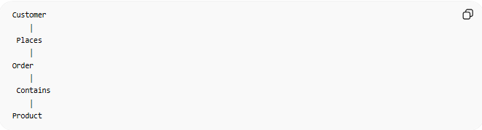
Customer
│
Places
│
Order
│
Contains
│
Product
Notice:

No tables
No columns
No data types
Only business concepts.

🏢 Real-World Example
# Source: AI Source: Provided by: [Data Path: Persons Table -> ID Column: 1, Name_En Column: Motasem Essam] -> From: [ChatGPT] on [6/10/2026]
University System
Entities:

Student
Course
Instructor
Department
Relationships:

Student enrolls in Course
Instructor teaches Course
Department manages Course

Conceptual Diagram

Student
│
Enrolls In
│
Course
│
Taught By
│
Instructor

🧩 Main Components
# Source: AI Source: Provided by: [Data Path: Persons Table -> ID Column: 1, Name_En Column: Motasem Essam] -> From: [ChatGPT] on [6/10/2026]
The Conceptual Model typically includes:
1. Entities
Examples:
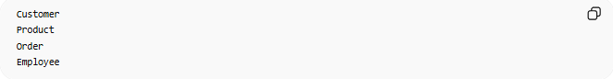
Customer
Product
Order
Employee

2. Relationships
Examples:
Customer places Order
Employee works in Department

3. Business Rules
Examples:
A customer can place many orders.
An order must belong to one customer.

❌ What is NOT Included?
# Source: AI Source: Provided by: [Data Path: Persons Table -> ID Column: 1, Name_En Column: Motasem Essam] -> From: [ChatGPT] on [6/10/2026]
A Conceptual Model does NOT include:
Tables

CREATE TABLE Customers
No.

Data Types

INT
VARCHAR
DATE
No.

Primary Keys
CustomerID
Usually not.

Database Engine

MySQL
PostgreSQL
Oracle
No.

📊 ER Diagrams
# Source: AI Source: Provided by: [Data Path: Persons Table -> ID Column: 1, Name_En Column: Motasem Essam] -> From: [ChatGPT] on [6/10/2026]
The most common tool used for Conceptual Modeling is an:
ER Diagram (Entity-Relationship Diagram)
Example:
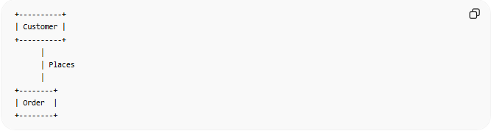
+----------+
| Customer |
+----------+
│
│ Places
│
+--------+
| Order |
+--------+
This shows:
- Entities
- Relationships
without implementation details.

🔢 Characteristics of a Conceptual Model
# Source: AI Source: Provided by: [Data Path: Persons Table -> ID Column: 1, Name_En Column: Motasem Essam] -> From: [ChatGPT] on [6/10/2026]
A Conceptual Model:
- High-level
- Business-focused
- Technology-independent
- Easy for non-technical users
- Focuses on requirements

🌍 Banking Example
Entities:

Customer
Account
Transaction
Relationships:
Customer owns Account
Account records Transactions
Conceptual Diagram:
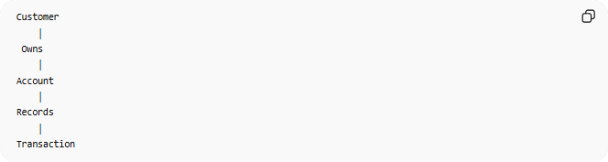
Customer
│
Owns
│
Account
│
Records
│
Transaction

🔄 Conceptual vs Logical vs Physical
# Source: AI Source: Provided by: [Data Path: Persons Table -> ID Column: 1, Name_En Column: Motasem Essam] -> From: [ChatGPT] on [6/10/2026]
Conceptual
Focus:
What data exists?
Example:
Customer places Order

Logical
Focus:
How is data structured?
Example:
Customers Table
Orders Table

Physical
Focus:
How is data stored?
Example:
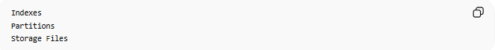
Indexes
Partitions
Storage Files

📊 Comparison
# Source: AI Source: Provided by: [Data Path: Persons Table -> ID Column: 1, Name_En Column: Motasem Essam] -> From: [ChatGPT] on [6/10/2026]
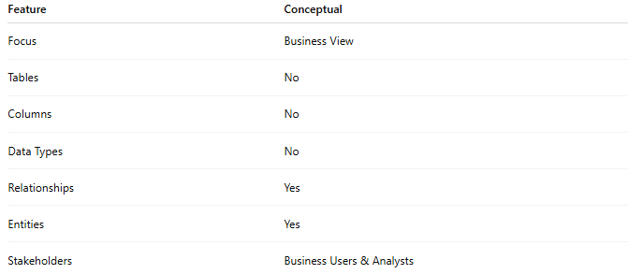
Feature | Conceptual
Focus | Business View
Tables | No
Columns | No
Data Types | No
Relationships | Yes
Entities | Yes
Stakeholders | Business Users & Analysts

🧠 Simple Analogy
# Source: AI Source: Provided by: [Data Path: Persons Table -> ID Column: 1, Name_En Column: Motasem Essam] -> From: [ChatGPT] on [6/10/2026]
Think about designing a house.
Conceptual Stage
You discuss:
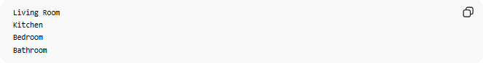
Living Room
Kitchen
Bedroom
Bathroom
and how they connect.
You do NOT discuss:
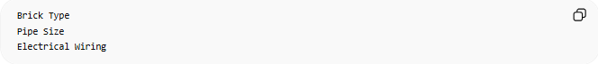
Brick Type
Pipe Size
Electrical Wiring
Those details come later.
The Conceptual Data Model works the same way.

🧭 Summary
# Source: AI Source: Provided by: [Data Path: Persons Table -> ID Column: 1, Name_En Column: Motasem Essam] -> From: [ChatGPT] on [6/10/2026]
A Conceptual Data Model is a high-level representation of business data requirements. It focuses on entities, relationships, and business rules without considering tables, columns, data types, or database technology. It is commonly represented using ER Diagrams and serves as the foundation for logical and physical database design.

